**Particle Swarm Optimization feature selection for data stream mining.**

Prof. Ram B. Joshi.

Dept. of Computer, Head of department, Indira college of Engineering and Management, SPPU, Pune, India

Snehal Vilas Rode.

Student, Dept. of Computer., Indira college of Engineering and Management, SPPU, Pune, India

**ABSTRACT**: Big data concept is used in every industry or any business. Big data can be characterized by 3Vs: the extreme volume of data, the wide variety of types of data and the velocity at which the data must be processed. Although big data doesn't refer to any specific quantity, the term is often used when speaking about petabytes and Exabyte of data, much of which cannot be integrated easily. Big data contains not only the challenges that are coming from academic research communities but also commercial IT deployment, the root sources of Big Data are founded on data streams and the curse of dimensionality. It is generally known that data which are sourced from data streams accumulate continuously making traditional batch-based model induction algorithms infeasible for real-time data mining. Feature selection allows us to selection of data through its features we can filter the data using their features. But when the large dataset come the feature selection becomes complicated, and for the high dimension of data the feature which are used to fi9lter are also increased.

KEYWORDS: Particle Swarm Optimization, Swarm Intelligence, Classification, Big data.

1. **Introduction**

People tend to invest in stock of a company due to its high rate of return. However, stock prices are continuously changing and most investors including experienced investors fail to understand the market trends. Investors are often influenced by crowd psychology and tend to go with majority decision of buying or selling stock which may be against the current market trend.

Hence, an effective financial system is required which can make objective decision of whether to buy or sell the stock. There are many prediction methods available for making stock prediction such as chartist method, regression analysis and neural networks. This project application uses the PSO for data optimization, feature selection and data mining for modeling the stock because of its ability to learn from the given training data and then generalize a rule.

The principal strength with the network is its ability to find patterns and irregularities as well as detecting multi-dimensional non-linear connections in data. The model is trained using the historical daily stock quotes of at-least two years. The historical stock quotes can be fed directly through the Yahoo Finance Server using internet or from the local database. Once the model is successfully trained, the model can be used to predict the value of share in future. This allows the investors to reduce the risk of investing, and enables easier decision making resulting in maximum financial gain[1].

The brain is a multi-layer structure (think 6-7 layers of neurons, if we are talking about human cortex) with 10^11 neurons, structure, that works as a parallel computer capable of learning from the "feedback" it receives from the world and changing its design (think of the computer hardware changing while performing the task) by growing new neural links between neurons or altering activities of existing ones. To make picture a bit more complete, let's also mention, that a typical neuron is connected to 50-100 of the other neurons, sometimes, to itself, too.

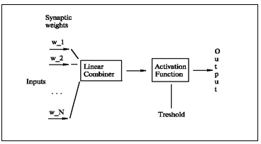

This project mainly focuses on data optimization which will be given input to feature selection, and points out the shortage that exists in current traditional statistical analysis in the stock, then makes use of PSO for data optimization, feature trend selection and then uses Data mining algorithm to predict the stock market by establishing a three-tier structure of the neural network, namely input layer, hidden layer and output layer. After building the data pre-processing set before data mining, lots of widely used stock market technical indicators. Finally, we get a better predictive model to improve forecast accuracy.

In this project, we apply data mining technology to Indian stock market in order to research the trend of price, it aims to predict the future trend of the stock market and the fluctuation of price. Neural network is used to optimized the data, The Neural Networking algorithms (at least some of them) are modeled after the brain (not necessarily - human brain) and how it processes the information. The brain is a very efficient tool. Having about 100,000 times solver response time than computer chips, it (so far) beats the computer in complex tasks, such as image and sound recognition, motion control and so on. It is also about 10,000,000,000 times more efficient than the computer chip in terms of energy consumption per operation.

A neuron is an electrically excitable cell that processes and transmits information through electrical and chemical signals. Our "artificial" neuron will have inputs (all N of them) and one output: Set of nodes that connects it to inputs, output, or other neurons, these nodes are also called synapses.

Specifically, this paper makes the following contributions:

* Data optimization of the data which will be given input to the data mining.
* Till now Particle swarm optimization is exist only for the ECG system, this paper present PSO for the stock market dataset, so whatever data will be given for feature extraction is already optimized so that the accurate feature will be extracted and the prediction will be more accurate.

This paper continues to exist as follows: section II presents related work Section III is about design details of proposed PSO system. Finally the paper concludes in section V.

Hence, an effective financial system is required which can make objective decision of whether to buy or sell the stock. There are many prediction methods available for making stock prediction such as chartist method, regression analysis and neural networks. This project application uses the PSO for data optimization, feature selection and data mining for modeling the stock because of its ability to learn from the given training data and then generalize a rule.

The main purpose of energy efficient algorithm is to maximize the network lifetime. These algorithms are not just related to maximize the total energy consumption of the route but also to maximize the life time of each node in the network to increase the network lifetime. Energy efficient algorithms can be based on the two metrics: i) Minimizing total transmission energy ii) maximizing network lifetime. The first metric focuses on the total transmission energy used to send the packets from source to destination by selecting the large number of hops criteria. Second metric focuses on the residual batter energy level of entire network or individual battery energy of a node [1].

1. **Related work**

## **Collaborative filtering**

Collaborative filtering: This method is based on the user behavior and prediction. The fundamental concept is that collect the opinion from the other users, in such a way to provide some prediction about the active user prediction. For example, if one person like item which is like by group of other person then he will likely agreed upon the item which is like by that same group. Two types of Collaborative

* Memory based Collaborative filtering

Another name is lazy recommendation algorithm. It calculates the customer prediction for an object when customers ask for collection of recommendation. Hence algorithms need to store the customer rating information in memory. There are two different algorithm based on k-nearest algorithm: 1.Item based filtering, 2. Customer based filtering Item based filtering method is based on the most similar items/objects. The item is considered for similarity when same group of customer ranked them highly. For every item which belong to a current customer, the neighborhood of same object is considered and every top k-neighbor are put on the list, and recommendation are present to active user. Customer based filtering compare the active customer/user to the other neighbor which have a past concurrence with the active user. First all neighbor are find out and then the entire object which belongs to neighbor which are strange for active customer are regarded as a suggestion.

* Model based Collaborative Filtering:

This method is based on the dataset of rating, where we extract information from dataset, and use that as a model to calculate recommendation with no use of entire dataset which benefits of both speed and scalability.

**B. Tuple based recommendation system**

Recommendation system used the query log registry which stored history of every old user who was use this system. And tuple based system used the data which is retrieved from previously executed query. Every successfully executed query and there result are stored with the all output which contains tuple data. The downside of this system is increase complexity. The size of data increases linearly with increasing session summary. And every time we want to compare the current user session data with previous user stored data.

**C. Fragment based recommendation system**

This method implementation is same as the Tuple based recommendation method. The main difference is in method of session data comparison. In fragment base system, we use fragments of query instead of the witness means all tuple included data. In this method entered query is fragmented and those fragments are used to comparison. This method gives better result than tuple based recommendation.

**D. Traditional and incremental approach**

As the size of database increases the feature set also increases. Traditional system approach contains classification approach using top-down supervised learning Traditional classification approach, where a full set of data is used to construct a classification model, by recursively partitioning the data into forming mapping relations for modelling a concept. The previous model is based on stationary dataset so whenever new item comes model update needs to repeat the whole training process. Since these models are built based on a stationary dataset, model update needs to repeat the whole training process whenever new samples arrive, adding them to incorporate the changing underlying patterns. The traditional models might have a good performance on a full set of historical data, and the data are relatively stationary without anticipating much new changes. In dynamic stream processing environment, however, data streams are ever evolving and the classification model would have to be frequently updated accordingly. Therefore a new generation of algorithms, generally known as incremental classification algorithms or simply, data stream mining algorithms has been proposed to solve this problem.

1. **SYSTEM ARCHITECTURE**

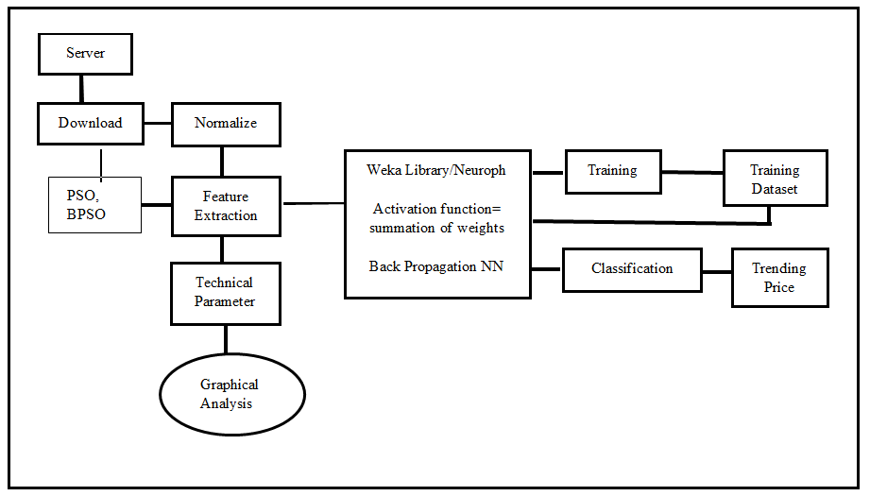

Fig.2. System Architecture

In this system the data input is downloaded from the server and given to the normalize module, the data is also given to the PSO and BPSO module which will optimize the data , the combination of both normalize data and the output of PSO and BPSO is given as a input to the feature extraction module. Technical parameters are nothing but the graphical comparison of data it will check the data by graph and the analysis or the differences are taken from the measure, so the feature extraction contains the input of the normalize, PSO & BPSO , technical parameters the output of the feature extraction module are given to the back propagation algorithm which will contains the activation function which is summation of weights, the output is given to the training module which contains the patterns that are occurring against the time of period according to that the training dataset is created and given back to the module, then the classification is done for the calculating the price means the pattern is checked for the classification and then the trending price will be given to the end user.

1. **Pseudo code**

**Algorithm 1: Backpropagation Algorithm**

1) Assign all network inputs and output

2) Initialize all weights with small random numbers, typically between -1 and 1

3) Repeat

3.1) for every pattern in the training set

3.2) present the pattern to the network

3.3) for each layer in the network

for every node in the layer

1. Calculate the weight sum of the inputs to the node

2. Add the threshold to the sum

3. Calculate the activation for the node

End

End

3.4) for every node in the output layer calculate the error signal

End

3.5) for all hidden layers for every node in the layer

1. Calculate the node’s signal error

2. Update each node’s weight in the network

End

End

End

While ((maximum number of iterations i than specified) AND (Error Function than specified))

**Algorithm 2: Calculating weight using neural network**

1) Randomly choose the initial weights

2) INITIALIZE ERROR VAL

3) NORMALIZE STOCK VALUE STKVAL = STKVAL/MAX VAL

4) LOOP While error is too large ( ERROR VAL = 0.5) For each training pattern (Set Input 4 Value and Set Desired )

5) Apply the inputs to the network

6) Calculate the output for every neuron from the input layer, through the hidden layer(s), to the output layer

7) Calculate the error at the outputs

8) Use the output error to compute error signals for pre-output layers

9) Use the error signals to compute weight adjustments

10) Apply the weight adjustments

11) END LOOP

12) Periodically evaluate the network performance

**Algorithm 3: Particle swarm optimization**

1) Initialize the particles with random velocities and positions in a given Dimension.

2) Compute the fitness of all particles using the desired benchmark function, choose the lowest one as global best and assign the current positions of all particles as their best.

3) Calculate the next velocities and positions using the equations 1 and 2.

4) Calculate the fitness of all particles using the updated velocities and positions. If the new fitness is less than the particles best fitness, the new fitness is considered the best one. In the same way the new position is considered the particle best position.

5) In the same way if the new particle’s best fitness is less than the overall global best fitness, it is considered the new best global fitness and its corresponding position is considered new global best position.

6) Repeat third step for desired number of function evaluations.

1. **MATHEMATICAL MODEL**

The proposed system S is defined as follows: S = I, O, F

Where

I: Input

O: Output

F: Functions

U: User

Where

I= R, ND, OD

Where

R= Report of stock data

ND= Normalized data

OD= Optimized data

O = OD, FS, CD, TT, TP

Where

OD = Optimized data

FS = Features Set.

CD = Classified data.

TT = Training tuple.

TP = Trending Price.

F = PSO, BPSO, BP

Where

PSO = Particle swarm optimization

BPSO = B-Positive Particle Swarm Optimization

BP= Back Propagation

1. **Simulation Results**

## **System Implementation (Pre-processing)**

The prototype of the proposed system is implemented using java.

**Filter**

The Data collected by the sensor is filtered using High Pass and Low Pass Filter. The filtered data is further given for Feature extraction Process

**Feature Extraction Normalization Process**

The Filtered data is normalized using the below feature extraction methods

I. Standard deviation of the NN The simplest variable to calculate is the SDNN that is the square root of variance. Since variance is mathematically equal to total power of spectral analysis, SDNN reflects all the cyclic components responsible for variability in the period of recording. In many studies, SDNN is calculated over a 24 hours period and thus encompasses both short-term high frequency variation, as well as the lowest frequency components seen in a 24-hours period, as the period of monitoring decreases, SDNN estimates shorter and shorter cycle lengths. It should also be noted that the total variance increases with the length of analyzed recording. Thus SDNN is not a well-defined statically quantity because of its dependence on the length of recording period. Thus, in practice, it is inappropriate to compare SDNN measures obtained from recordings of different durations.



II. Standard deviation of differences between adjacent NN intervals. The most commonly used measures derived from interval differences include the standard deviation of differences between adjacent NN intervals. Calculation of standard deviation is show in above equation.

III. Root mean square successive difference of intervals the most commonly used measures derived from interval differences include the square root of the mean squared differences of successive NN intervals. Calculation of root mean square is show in equation.

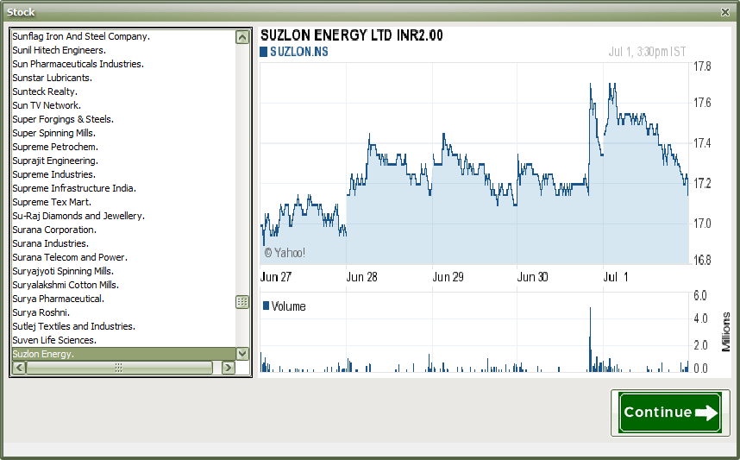

Fig: Stock analysis based on time period



Fig: Stock selection

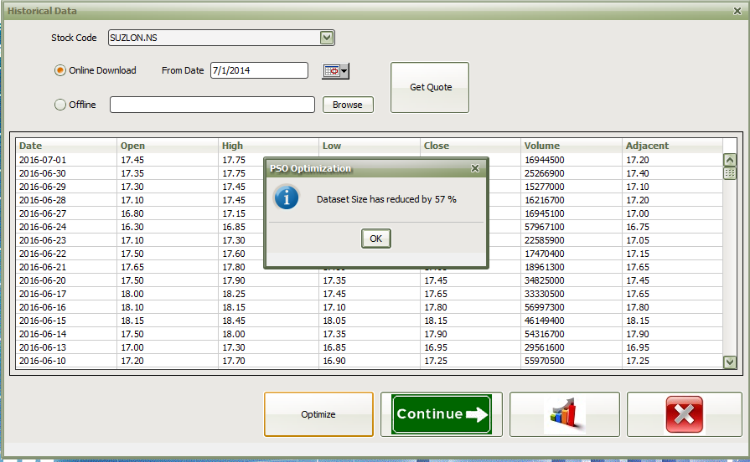

Fig: Data reduction.

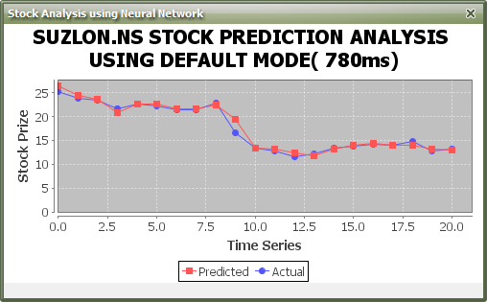

Fig: Prediction without using PSO (Time difference).

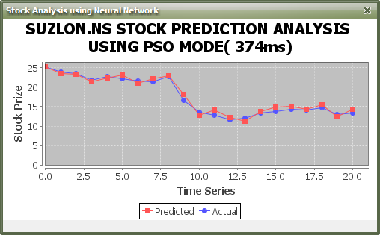

Fig: Prediction with using PSO (Time difference).

A mutual fund is a pool of money from numerous investors who wish to save or make money just like you. Investing in a mutual fund can be a lot easier than buying and selling individual stocks and bonds on your own. Investors can sell their shares when they want. By investing in mutual funds, you could diversify your portfolio across a large number of securities so as to minimize risk. By spreading your money over numerous securities, which is what a mutual fund does, you need not worry about the fluctuation of the individual securities in the fund's portfolio. A closed-end fund has a fixed number of shares outstanding and operates for a fixed duration (generally ranging from 3 to 15 years). The fund would be open for subscription only during a specified period and there is an even balance of buyers and sellers, so someone would have to be selling in order for you to be able to buy it. Closed-end funds are also listed on the stock exchange so it is traded just like other stocks on an exchange or over the counter. Usually the redemption is also specified which means that they terminate on specified dates when the investors can redeem their units. An open-end fund is one that is available for subscription all through the year and is not listed on the stock exchanges. The majority of mutual funds are open-end funds. Investors have the flexibility to buy or sell any part of their investment at any time at a price linked to the fund's Net Asset value.

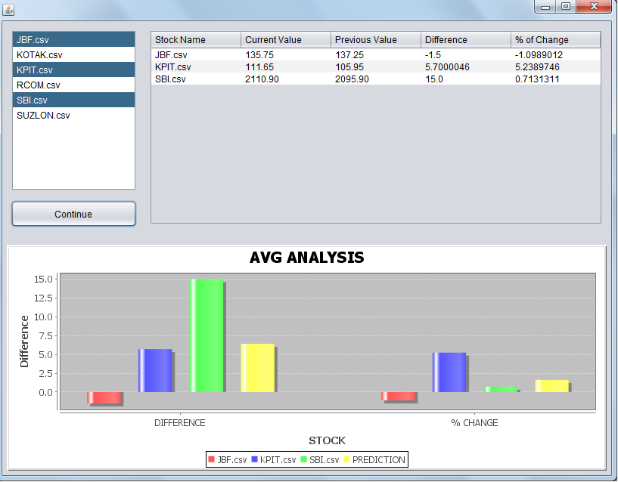

Fig: Mutual fund result analysis.

1. **CONCLUSION**

My present working is based on the optimizing the data that is feed to the prediction system and that will help people in analyzing the market condition. Challenging task is the amount of data daily feed into system is tremendous, and the share of different companies changes continuously so it need to be real time and the data must be updated according to time. There are different types of attribute which vary according to industry type so that parameter also need to be taken into consideration. The multi-objective PSO-based feature selection approach to better explore the Pareto front of non-dominated solutions in feature selection problems. To investigate the use of B-positive multi-objective PSO for feature selection and compare its performance with that of continuous multi-objective PSO.

**ACKNOWLEDGEMENT**

Thanks to all those who helped me in completion of this work knowingly and unknowingly, all those who directly or indirectly the researchers, my lectures and friends.

**REFERENCES**

1. Ping-Feng Pai, Tai-Chi Chen, "Rough set theory with discriminant analysis in analyzing electricity loads", Expert Systems with Applications 36 (2009), pp.8799–8806
2. Simon Fong, Raymond Wong, and Athanasios V. Vasilakos, Accelerated PSO Swarm Search Feature Selection for Data Stream Mining Big Data IEEE TRANSACTIONS ON JOURNAL NAME, MANUSCRIPT ID
3. S. Ray, R.H. Turi, Determination of Number of Clusters in K-Means Clustering and Application in Color Image Segmentation, Proceedings of the 4th International Conference on Advances in Pattern Recognition and Digital Techniques (ICAPRDT'99) , Calcutta, India, 137-143, 1999.
4. Hart, P. E., Nilsson, N. J., & Raphael, B., 1968. A Formal Basis For The Heuristic Determination Of Minimum Cost Paths. Systems Science and Cybernetics, IEEE Transactions on, 4(2), 100-107.
5. Hereford, J. M. (2006). A distributed particle swarm optimization algorithm for swarm robotic applications. Paper presented at the Evolutionary Computation, 2006. CEC 2006. IEEE Congress on.
6. Eberhart, R., & Kennedy, J. (1995). A new Optimizer using particle swarm theory. Paper presented at the Micro Machine and Human Science, 1995. MHS'95., Proceedings of the Sixth International Symposium on.
7. S. Ray, R.H. Turi, Determinati on of Number of Clusters in K-Means Clustering and Application in Color Image Segmentation, Proceedings of the 4th International Conference on Advances in Pattern Recognition and Digital Techniques (ICAPRDT'99), Calcutta, India, 137-143, 1999.
8. I.H. Witten, E. Frank, Data mining: practical machine learning tools and techniques with Java implementations, Morgan Kaufmann (2005), J.S Bridle, “Probabilistic Interpretation of Feedforward Classification Network Outputs, with Relationships to Statistical Pattern Recognition,” Neurocomputing—Algorithms, Architectures and Applications, F. Fogelman-Soulie and J. Herault, eds., NATO ASI Series F68, Berlin: SpringerVerlag, pp. 227-236, 1989.